GROUP I

24/06531
MOSHE DAYAN
INTRODUCTION TO PROGRAMMING
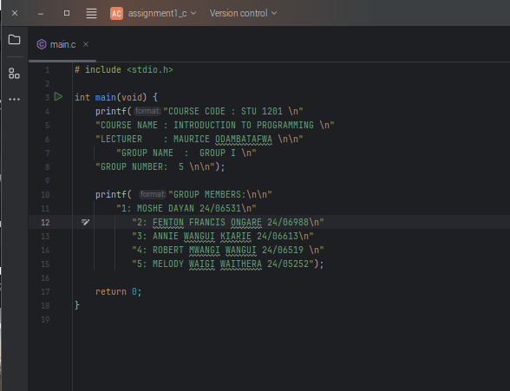
ASSIGNMENT 1

